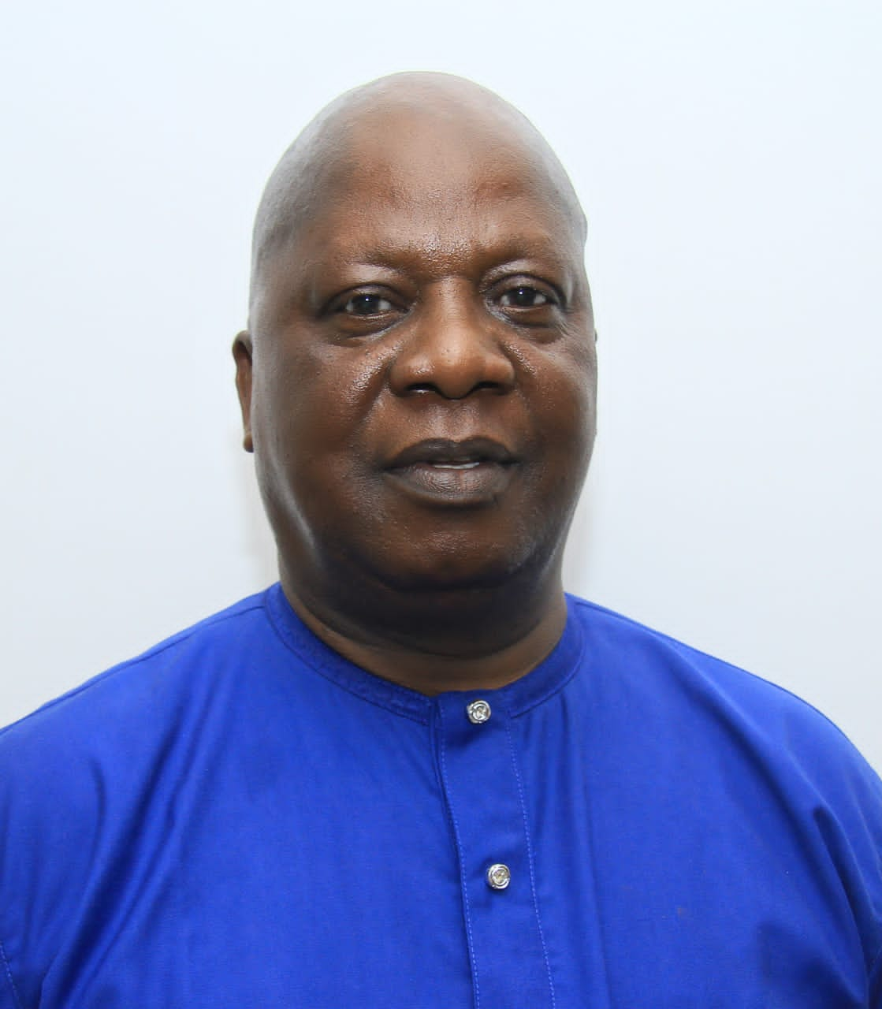

**MR. BEN OLAOYE, ELDER-IN-COUNCIL**